Homework # B : TinyDB Vs SQLite Final Report

Ruchi Panwar(rpanwar@kent.edu)

Software Testing

Fall 2015

Professor: Dr. Gregory S DeLozier

Nov 5th, 2015

**Introduction**

TinyDB is a tiny, document oriented database. It is designed to be simple and fun to use by providing a simple and clean API. Its written in python and does not need any external severs such as PyMongo.

**Purpose**

This Test Report provides a summary of the results of tests performed to verify whether the TinyDB is better than SQLite.

**Test Results**

|  |  |  |  |  |
| --- | --- | --- | --- | --- |
| **TinyDB Vs SQLite - Test Plan Results** | | | | |
| **Sr. No** | **Test Description** | **Status - TinyDB** | **Status - SQLite** | **Comments** |
| 1 | Create a table and insert the data | Completed | Completed | Works fine for both. |
| 2 | Retrieve one record from the table. | Completed | Completed | Works fine for both. |
| 3 | Retrieve all the records from the table. | Completed | Completed | Works fine for both. |
| 4 | Retrieve one column from the table. | Completed | Completed | In TinyDB, No such function available to retrieve one column data. |
| 5 | Retrieve all the Columns from the table. | Completed | Completed | Works fine for both. |
| 6 | Delete one record from the table. | Completed | Completed | Works fine for both. |
| 7 | Delete all the records from the table. | Completed | Completed | In TinyDB, No such function available to retrieve one column data but you can delete the table using Purge() function. |
| 8 | Update one or multiple records into the table. | Completed | Completed | Works fine for both. |
| 9 | Check whether the values can be roll-backed in case of error. | Completed | Completed | In TinyDB, No such function available to rollback the data. |
| 10 | Check whether the table has fixed structure or dynamic structure. | Completed | Completed | SQLite - Fixed Structure  TinyDB - Dynamic Structure |
| 11 | Check the performance of the database while inserting and retrieving the records. | Completed | Completed | TinyDB - Performance is really bad. |

**Test Report**

**Case 1: Create a table and insert the data.**

As you can see in the below screen shots, in both the cases the insert operation is working.

**TinyDB:**

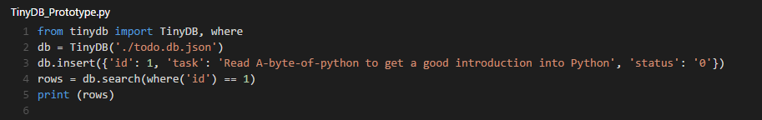

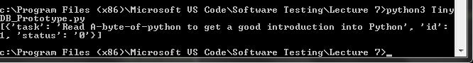

**SQLite:**

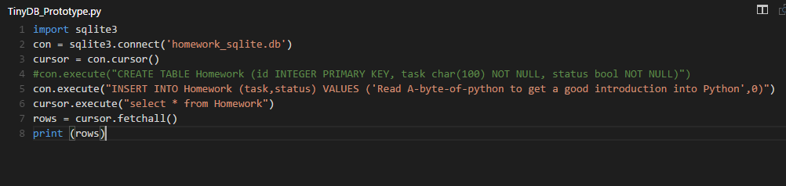

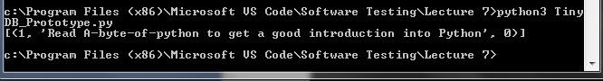

**Case 2: Retrieve one record from the table.**

**TinyDB:** db.get() function can be used to retrieve one record.

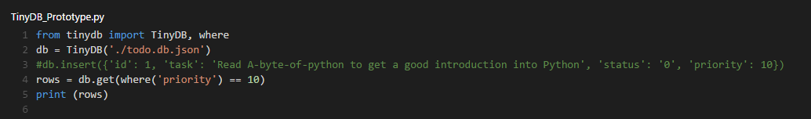

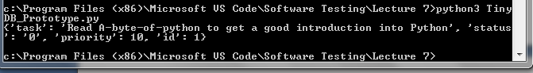

**SQLite:** fetchone() function can be used to retrieve one record.

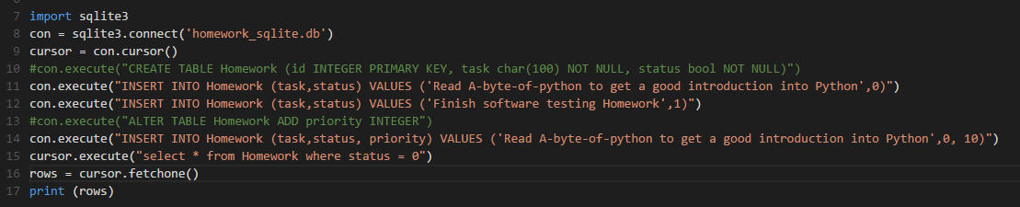

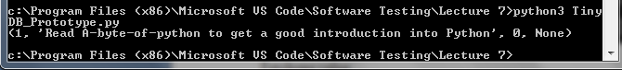

**Case 3: Retrieve all the records from the table.**

**TinyDB:** db.search() function can be used to retrieve all the records.

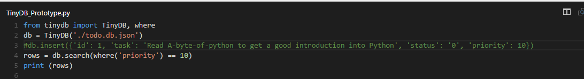

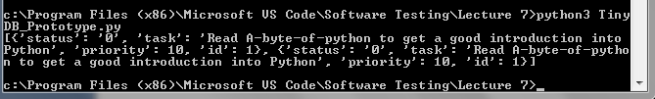

**SQLite:** fetchall() function can be used to retrieve all the records.

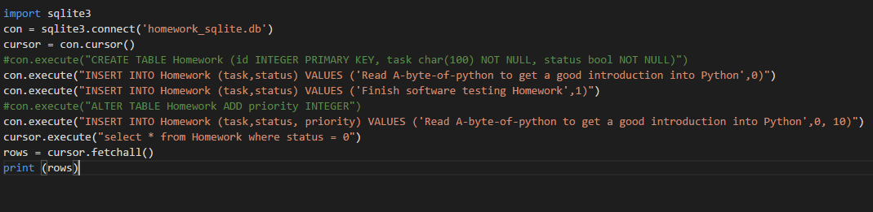

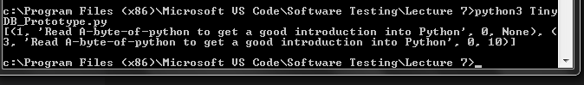

**Case 4: Retrieve one column from the table.**

**TinyDB:** There is no such function to get the value for one column**. T**ried to retrieve the value using get() and search() functions, but both the functions didn't work.

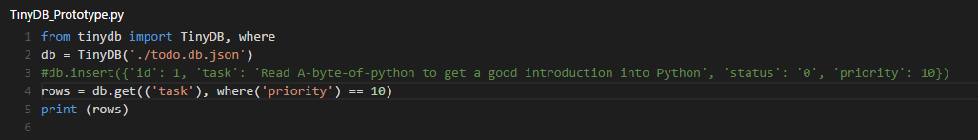



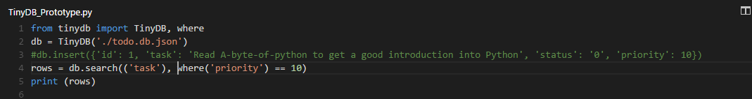

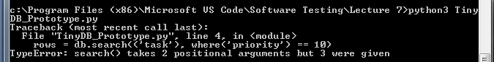

**SQLite: C**an be done easily by defining the name of the column while selecting the data.

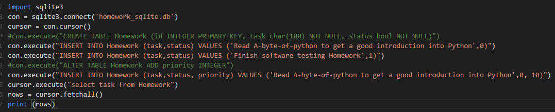

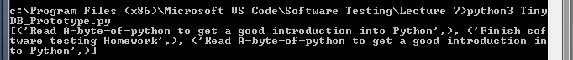

**Case 5: Retrieve all the Columns from the table.**

**TinyDB: B**y default it gives all the columns when retrieving the data.

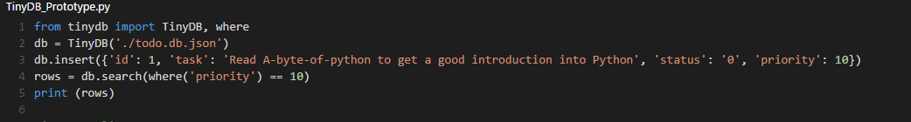



**SQLite:** Can be done easily by using *(wildcard entry) while selecting the data.





**Case 6: Delete one record from the table.**

**TinyDB:** Can be done easily by using remove() or Update(delete()) functions.

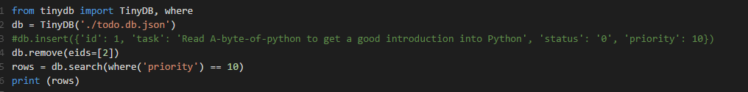



**SQLite:** Can be done easily by using DELETE FROM table command.

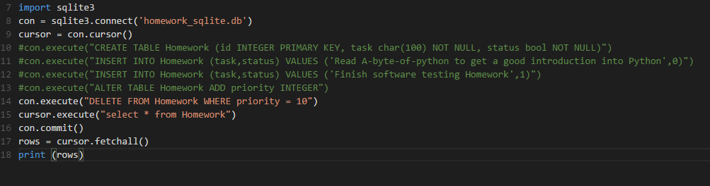

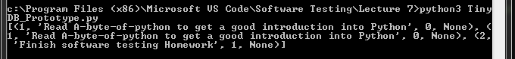

**Case 7: Delete all the records from the table.**

**TinyDB:** No such function is found to delete all the records from the table**.**

**SQLite:** Can be performed by not defining the "where" condition while deleting data from the table**.**

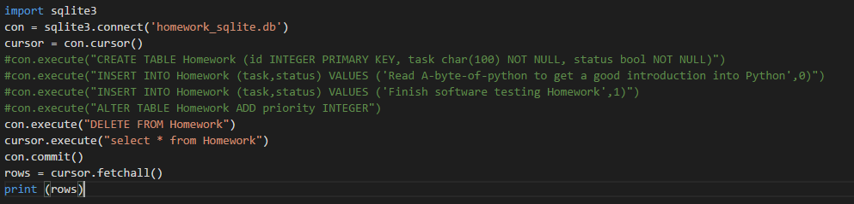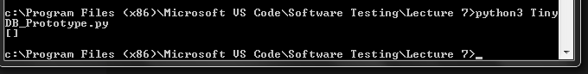

**Case 8: Update one or multiple records into the table.**

**TinyDB: C**an be done using UPDATE function.

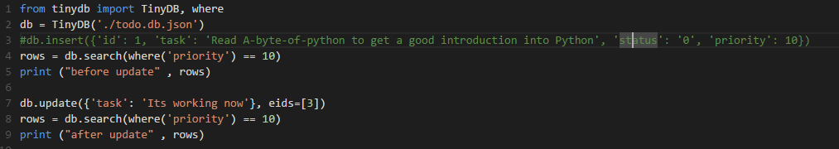

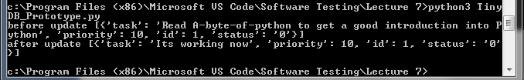

**SQLite:** Can be done using UPDATE command.

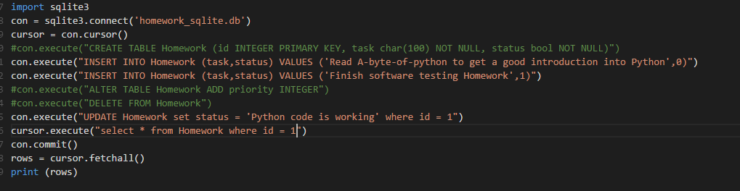



**Case 9: Check whether the values can be roll-backed in case of error.**

**TinyDB:** Couldn't find any function which canroll-back the data in case of error.

**SQLite:** can be done using rollback() function.

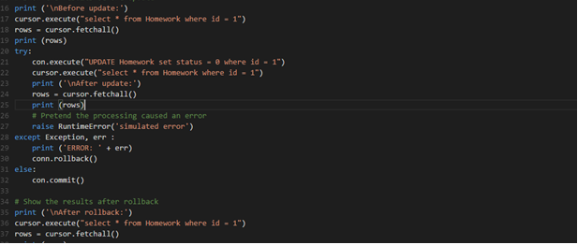

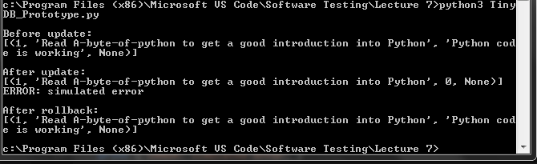

**Case 10: Check whether the table has fixed structure or dynamic structure.**

**TinyDB:** Very dynamic, no fixed structure. No extra effort needed to add new column values**.**



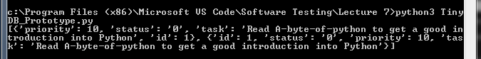

**SQLite:** Fixed structure. you have to use ATLER Table to add new columns, else you cannot add value for an extra column**.**

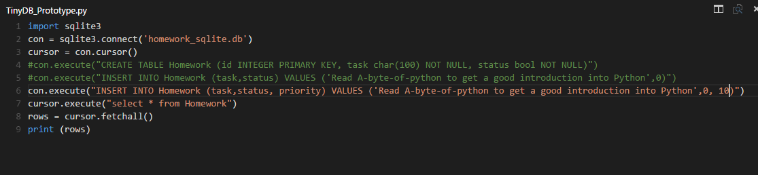

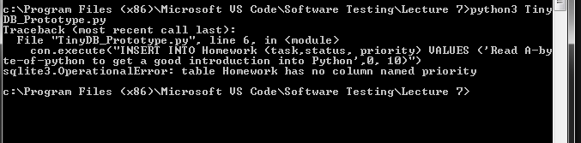

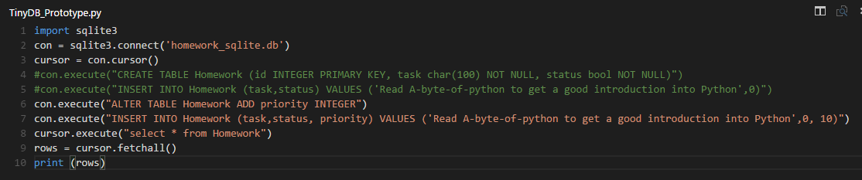

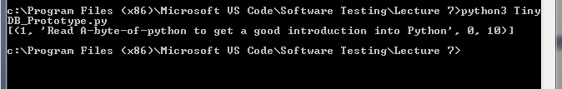

**Case 11: Check the performance of the database while inserting and fetching the records.**

**TinyDB:** Very bad performance, first tried to insert 10000 records, got crashed and only 3200 records got inserted then tried inserting 1000 record and fetching them all.

Insertion time for 1000 records was = 9min 38 secs.

Fetching time = 89000 ms.

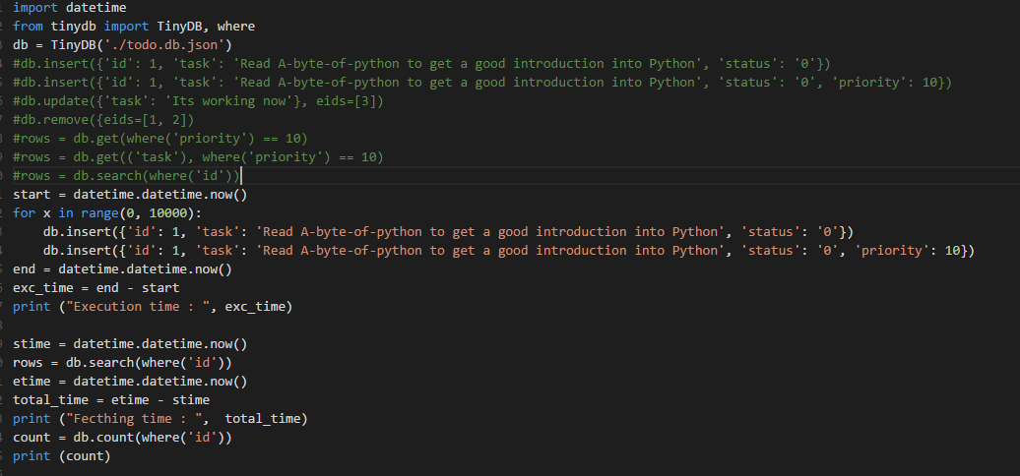



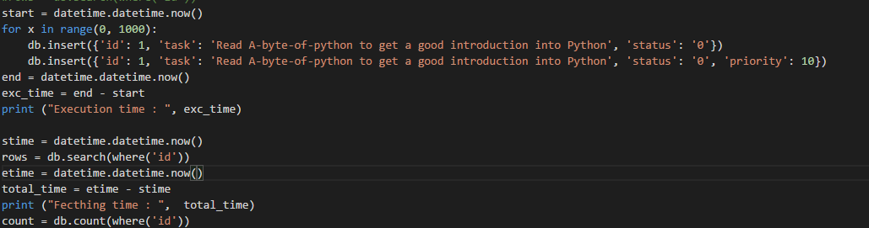

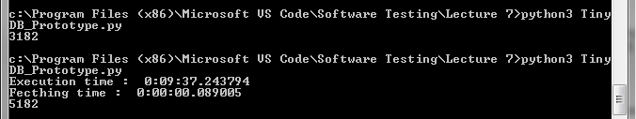

**SQLite:** Comparatively really fast, it could insert 20000 records into database just in 187000 ms and was able to retrieve 20000 records in 85000 ms whereas TinyDB took 89000 ms to fetch only 1000 records.

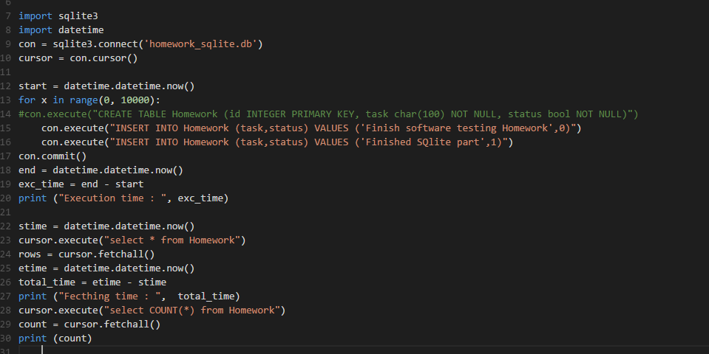

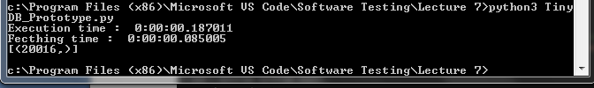

**Conclusion**

TinyDB works fine with very small set of records but when it comes to large amount of data, the performance is really bad. The query execution time is ten to fifteen times more than the SQLite.

TinyDB doesn't even have all the basic functions to play with the database such as functions to delete all the records, to roll-back the records or to retrieve one column from the table. On the contrary SQLite has load of functions available that are easy to use.

TinyDB surely is dynamic when it comes to structuring but doesn't seem to be a good choice even for small databases as its performance is really bad and doesn't even provide the basic features.

References

*https://* *www.google.com/\**

*https://docs.python.org/2/library/sqlite3.html*

*http://tinydb.readthedocs.org/en/latest/usage.html*

*http://tinydb.readthedocs.org/en/latest/intro.html*